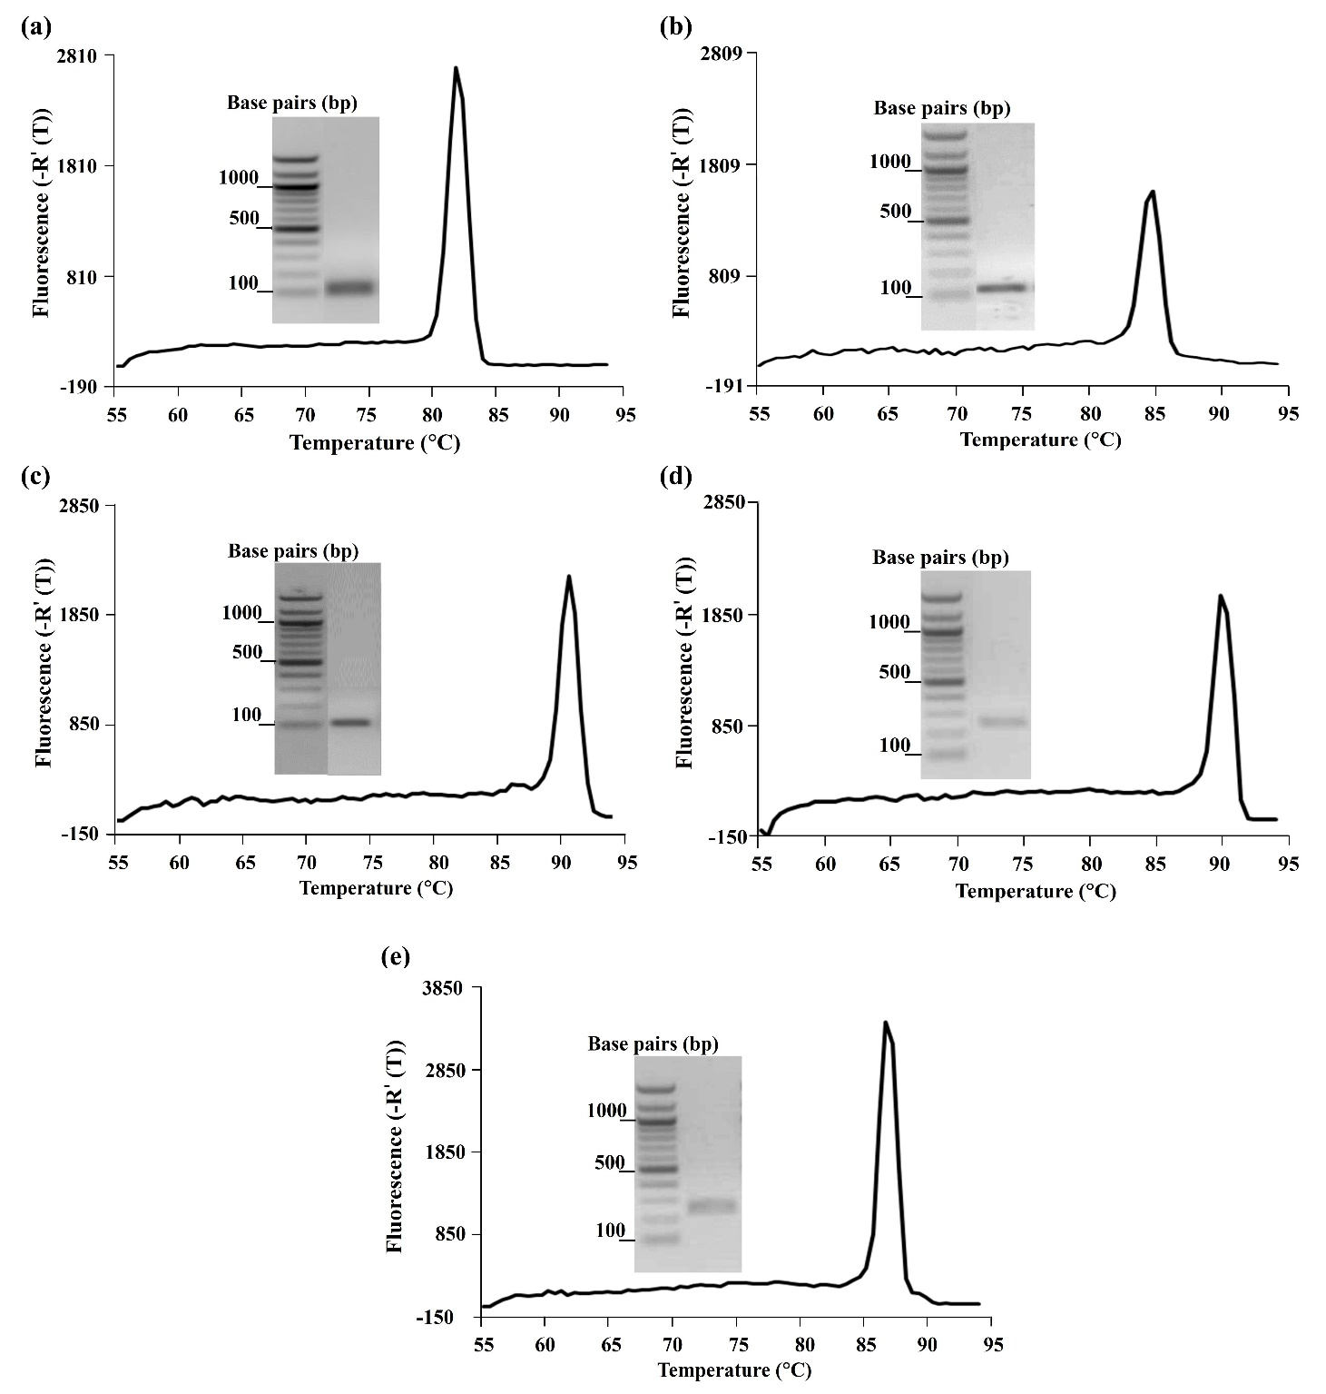

Supplement Figure 1. Analysis of assay conditions and primer specificity for the amplification of the cyp19 (a), tgase (b), dio (c), tr (d), and ß-actin (e) genes by real-time PCR. The main image displays the melting curve, which assesses primer specificity and confirms the presence of a single, specific product. The inset image shows the PCR product analyzed via agarose gel electrophoresis, demonstrating a single band of the expected size, confirming the purity and correct amplification of the DNA fragment.

