Research Article
Quantification of iodine in salt, foods; and determination of knowledge and pattern of consumption of iodine containing food materials in Sokoto State, Nigeria

Aminu Umar Imam¹ Yusuf Sarkingobir^{2*} and Ummu Tukur³
¹Department of Biochemistry, Sokoto State University, Sokoto, Nigeria
²Department of Environmental Education, Shehu Shagari University of Education Sokoto, Nigeria
³Department of Biology, Shehu Shagari University of Education Sokoto, Nigeria
*Corresponding author email: superoxidedismutase594@gmail.com

Date Received Date Revised Date Accepted
October 2, 2023 February 8, 2024 February 8, 2024

Abstract
The objectives were to assess iodine in food materials and commercial salts in Sokoto; assess consumption of iodine rich foods, and assess knowledge about iodine nutrition. Questionnaire was utilized to collect the qualitative data, and levels of iodine were determined with standard methods. The design was done in quasi experimental fashion. All study subjects passed through these stages of grouping exercise namely, pre-test group, Intact group and post-test group design. The levels of iodine in foods taken by respondents have shown disparities and all the iodine values across zones of the state are sufficient. Fish has the highest iodine (56.0 ± 7.01 - 100.1 ± 0.01ppm), then egg (50.1 ± 0.01- 60.0 ± 0.01ppm), then vegetable (39.5 ± 0.01 - 47.3 ± 6.1ppm), followed by chicken (32.7 ± 5.01-45.0 ± 0.001ppm), and lastly, milk (17.0 ± 4.01- 32.6 ± 5.01 ppm). Most of the salts contain adequate iodine. The pattern of the use of salt shows that, about 70% of respondents in Central Sokoto Zone (CSZ), 67.8% in Eastern Sokoto Zone (ESZ) and 69.6 % Western Sokoto Zone (WSZ) sometimes add salt to their meals. The consumption of iodine rich foods reveals, vegetables were the most consumed iodine containing food materials (compared to those that avoids vegetables in the zones of the state), the eggs, followed by milk, and lastly fish. Mostly, there are enough iodine in salts, enough consumption of iodine rich foods, and poor iodine nutrition education among the respondents. More iodine awareness is needed in the state.
Keywords: Iodine; salt; chicken; vegetables; thyroid; goiter

Introduction
In most of the cases, iodine is imported into the human body through the foods such as vegetables, salt, meat, egg, etc in forms such as iodides, iodates, molecular iodine, and organic monoatomic iodine. Firstly, iodine has to be trapped when iodine is moved from the capillary into the follicular cells of the thyroid gland using an active transport system powered by ATpase dependent Na+/ K pump [1, 2]. Secondly, thyroglobulin is made in an independent process in the follicular cell of the thyroid. This step begins on the rough endoplasmic reticulum via the peptide units (of about 330, 000 weight). In turn, the units formed a dimer, then incorporation of moieties of carbohydrate; then the molecule is taken to the Golgi body. A complete thyroglobulin has 140 tyrosine residues embedded to act as substrate in the manufacturing of thyroid hormones [1,2]. The thyroglobulin is stored in little vesicles that in turn reached the apical surface of the plasma membrane and then released to the lumen of the follicular. Thirdly, oxidation of iodide occurs. The iodide of the follicular is shuttle to the apical surface of the plasma membrane to reach the lumen, a shuttle facilitated by iodide/chloride transporter dubbed as pendrin. Then, the iodide is hastily converted to iodine. Then organification of thyroglobulin, and iodination of tyrosine present in the thyroglobulin take place. Invariably, addition of iodine at position 3 formed monoiodidotyrosine (MIT), and incorporation at position 5 yield diiodotyrosine (DIT). Coupling reaction that involves two DIT joining to T4 hormone, one MIT joined two DIT to form T3. Then thyroid hormones are preserved in the thyroid follicles in the colloidal state for a period of months

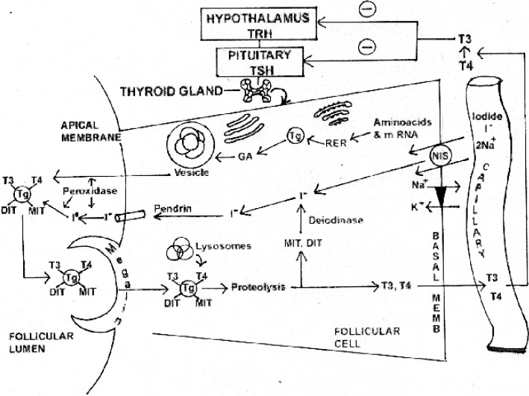

Figure 1: Showing metabolic pathways of iodine, Source: Ahad & Ganie, 2010

However, iodine deficiency occurs when there is insufficient iodine intake or inadequate iodine utilization [1,2]. Consequently, the essentiality of iodine as a micronutrient cannot be overemphasized. It is required by the human body to manufacture hormones, thyroxine, and triiodothyronine that are needed to regulate metabolism in cells during the transmogrification of oxygen to energy calories. The body cannot produce this vital element, rather obtained it from the foods that are available in the environment. The element is likewise an essential thing needed for normal development of brain, especially in children, and fetus [3].
However, lack of iodine in enough amount is a concern that results in many adverse consequences in human biological system and in turn affecting development, growth, and functions. The consequences due to iodine insufficiency are diverse such as endemic goiter, cretinism, hypothydrodism, low fertility, reduced intelligence, stillbirth, deaf-mutism, miscarriage, brain damage etc [4,5].
Worldwide, about 1.6 billion people are taking food that contains insufficient iodine, and in turn a public health concern that can be remedied by application of some amounts of iodine in salts or food or by taking food that contains iodine residues. Salt is a good carrier of iodine because most of the people take it regularly and it is a cheap commodity in the market. Other sources of iodine such as food, vegetable, fruit, meat, egg, milk are not the actual manufacturers of iodine because there are no enzymes to assemble the element from preformed materials rather the element was absorbed from the environment. Plants, for example got the element through water, soil. Likewise, animals take in plants, water, and other animals to supply the iodine into the body. In turn, the humans find the element through the food chain involving animals and plants [5,6,7,8].
Meanwhile, a surf of iodine and related studies across various parts of the world has shown that there is need to monitor the levels of iodine in common salts and the attitudes and practice of users of salts. Parable, Naeem et al., (2021) [7] performed a study on biofortication of rice variant with micronutrients including iodine, and found that the method is a good idea to tackle hunger and micronutrients deficiency as well. In a Southeastern study, it was revealed that, spices, grains, and vegetables are significant suppliers of iodine to the populace in the area especially the urban people [9]. Habib et al., (2021) [10] reported that, health education pertaining iodine should be inculcated in education avenues of the public and at community/ household levels. Likewise, a study from Kenya depicted that, there a challenges to universal salt iodization such as insufficiency of common salt iodization, poor implementation of iodine iodization laws, poor storage of salts, limited iodine nutrition knowledge, and expensive imported iodized salts [11]. In a study from Ghana, it was decried that, despite the formation of policies to tackle iodine levels in salts, the contents of iodine in salts in the study area were not appreciable. In turn recommending the regular checks on iodine content of sold salts and regular training of sellers on ways to preserve iodine content of salts [12].
Nevertheless, Umenwanne & Akinyele (2000) [13] decried that high iodine deficiency, lack of information in South-Eastern part of Nigeria are rampant. An analysis of iodine in the environmental sources in some villages of Anambra state, Nigeria was performed by Olife & Anajekwu (2013) [14]; therewith, cassava (a major foodstuff in that part of Nigeria) contains lower iodine (compared to the recommended standard) due to goitrogenic contents that aggravate iodine deficiency. Emilike et al., (2017) [3] in their work on effect of storage on salt iodine levels in Portharcourt, Nigeria decried that, storage of salts in open market styles (major markets in Nigeria) induces reduction in salt iodine concentrations, albeit salt is a major tool for intervening against iodine deficiency disorders in developing countries of the world. [15] in their study of iodine deficiency in children in Ilorin, Nigeria show that, a quarter of the participants still suffer from mild iodine deficiency despite the prevailing policies aimed at surmounting the problem. Moreover, a study concerning iodine deficiency among pregnant women attending a university hospital in Rivers state, Nigeria, indicates a predominant prevalence of iodine deficiency stressing the need for urgent supplementation [16]. A study from northern part of Nigeria, Sokoto Nigeria, shows that, inadequate iodine correlates with poor academic performance in girl children [17]. Likewise, a study of effects of goitrogens on iodine in various water sources in Sokoto, Nigeria, shows that water iodine concentrations in different zones of the state were mostly lower than the recommended standard amounts [18]. Thus, it has shown that monitoring iodine levels, knowledge and attitudes are vital in the policies to tackle iodine deficiency.

Objectives
To assess iodine in food materials and sold salts in Sokoto, investigate consumption of iodine rich foods, and assess knowledge about iodine nutrition.

Methodology
The study was carried out in Sokoto state, Nigeria. The exact location of the study was shown by the map in the Figure 2.
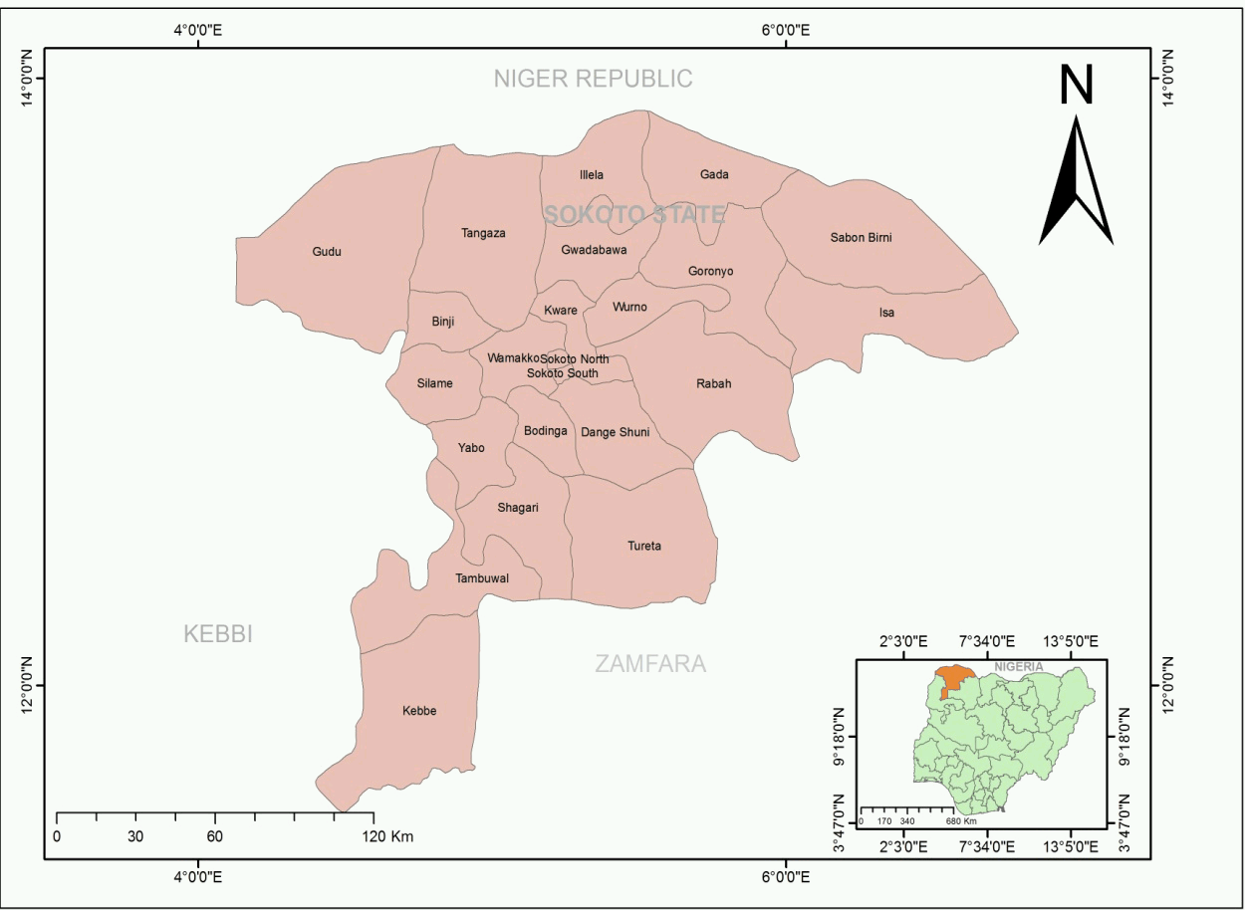

Figure 2: Map of the study location; Source: Sarkingobir et al (2023) [19].
Data collection
A structured questionnaire was employed among the participants and recorded their demographic characteristics, consumption of presumed iodine containing foods, and knowledge of iodine nutrition. Preliminarily, the questionnaire asked about the characteristic demographics of the participants. Section B asked about dietary styles of the participants. Section C asked about iodine deficiency knowledge. The sample size utilized was 246 participants.

Determination of iodine in salt
Procedure
Prior to taking a 10 g salt sample for analysis, the salt was thoroughly mixed in tightly sealed plastic bags to ensure that the iodine is homogeneously distributed in the salt. Ten grams (10g) iodated salt were dissolved in 50 ml distilled water, from which an aliquot (50 ml) was analyzed as mentioned in the titration step, without adjusting the concentrations of the reagents or calculation [4].

Titration
Once the salt was dissolved in the measured amount of water, sulfuric acid (1–2 ml) and potassium iodide (5 ml) were added to the salt solution. The reaction mixture was then kept in a dark place (with no exposure to light) for 5 to 10minutes to reach the optimal reaction time, before titration with sodium thiosulphate using starch (2 ml) as the indirect indicator. The solution turned deep purple. Titration was continued until the purple coloration disappeared and the solution became colorless. The concentration of iodine in salt was calculated based on the titrated volume (burette reading) of sodium thiosulphate using to the formula mentioned below
Iodine (ppm) = Titration volume in ml × 21.15× normality of sodium thiosulphate × 1000 (Muleta & Kibatu, 2016) [4].

Salt sample
Determination of Iodine content in fish, egg, fruit/vegetable, milk, chicken/meat
Iodine in foods (fish, egg, vegetables, milk, chicken) was determined using atomic absorption spectroscopy (AAS) as reported in Umar et al., (2023) [20].

Ethical Approval
This study was conducted according to guidelines that do not violate the rights of human subjects in research works. Equally, approval was sought from the Ethical Committee of the Department of Biochemistry, Usman Danfodiyo University, Sokoto. Additionally, the Ministries of Education and Health of Sokoto State approved the conduct of this study as well.

Statistical analysis
The descriptive statistics, chi-square test, and one-way analysis of variance were carried out at(p<0.05) significance level using Microsoft excel.

Results and discussion
The results for this study were shown in Tables 1-5.

Table 1: Showing demographic characteristics of respondents
Demographic characteristics | Central Sokoto Zone (CSZ)  No of Subjects (Percentage (%)) | Western Sokoto Zone (WSZ)  No of Subjects (Percentage (%)) | Eastern Sokoto Zone (ESZ)  No of Subjects (Percentage (%))
Age
14 | 20 (24.1) | 25 (31.6) | 25 (29.8)
15 | 24 (28.9) | 23 (29.1) | 23 (27.4)
16 | 20 (24.1) | 19 (24.1) | 20 (23.8)
17 | 19 (22.9) | 12 (15.2) | 16 (19)
Religion Islam | 68 (81.9) | 69 (87.3) | 72 (85.7)
Christianity | 15 (18.1) | 1 (12.7) | 12 (14.3)
Tribe
Hausa | 38 (45.8) | 42 (53.2) | 39 (46.4)
Yoruba | 4 (4.8) | 3 (3.8) | 1 (1.2)
Igbo | 3 (3.6) | 2 (2.5) | 1 (1.2)
Fulani | 18 (21.7) | 19 (24.1) | 8 (9.5)
Gobirawa | 16 (19.3) | 8 (10.1) | 29 (34.5)
Others | 4 (4.8) | 5 (6.3) | 6 (7.1)
Class
S.S.I | 46 (55.4) | 49 (62) | 50 (59.5)
S.S.II | 37 (44.6) | 30 (38) | 34 (40.5)

The demographic characteristics of the study subjects are shown in Table 1. More than half (141 subjects) of 246 study participants were aged between 14 to 15 years (of which 53% are from SCZ, 60.7% from WSZ and 57.2% from ESZ). Less than half (106 subjects) of 246 study subjects were within the age bracket of 16 to 17 years of which 47% were in SCZ, 39.3% in WSZ and 42.8% in ESZ. Mostly, the participants are Muslims, most of the participants are Hausa by tribe, others are Fulani, and few are Igbo and Yoruba by tribe. And the participants in Senior Secondary One (SS1) are more than those in Senior Secondary 2 (SS2). Showing that, they are at stages of development that require enough nutrients for proper growth and development. Failure to acquire proper and enough nutrients may have life-long consequences as well and hamper the socioeconomic potentials of the youngsters and ultimately affect the entire society.

Figure 3: Iodine levels of salts obtained from Retailers in selected communities in SCZ, SWZ and SEZ showing the proportion of iodine level in salt samples with various degree of iodine status. Inadequate iodine level in salt (<15ppm) and adequate iodine level (>15ppm)

From the Figure 3, it has been shown that, majority of the salts obtained from retailers contain adequate amount of iodine. Few of the salts drawn from various regions of Sokoto were having inadequate iodine levels (below 15ppm), with salt brought from Sokoto East as having the highest iodine insufficiency (below 15ppm). Similar to the findings of this study, a recent study conducted by Moyibo (2018) [21] has shown that there is continuous compliance in adding enough iodine in salts that is with the hands of retailers in Nigeria. However, the levels of iodine found by this study (Figure 3) are lower than the range found by Moyibo (2018) [21] and Emelike et al., (2017) [3]. This could be due to difference in brands, length of storage, diverse storage methods, and diverse processing of salts that were analyzed in the two different studies [3,21]. Salts that are stored under sunlight or wind experience reduction in some amount of iodine content [3,21]. The presence of enough iodine in most of the salts in the state should be properly utilized to inform the public to take in enough salt to avoid iodine deficiency, because lack of awareness could deter people from using enough salts. Likewise, the presence of low iodine in some salts corroborates with the view of Fan et al., (2022) [5] that some salts are not fortified even in developed countries like China. In a similar study in Kenya, it was reported that some of the salts analyzed contain no iodine [4]. The few salts with low iodine should be shun or people need to take other measures to improve their iodine levels by taking other iodine rich foods and avoiding goitrogens as able as possible. all of these cannot be achieved except with awareness or health education among the residents [5]. Universal application of iodine in salts in a view to address iodine deficiency is a historic tradition because both low and excess iodine situations are behind thyroid diseases or iodine deficiency; and even mild iodine deficiency is harmful to health, therefore it is pertinent to take right amount of iodine intake always especially the one taken in salts that are common [5].

Table 2: Pattern of Use of salt by Study Subjects in Three Zones of Sokoto State
Variable | Central Sokoto Zone  Frequency (%) | Western Sokoto Zone  Frequency (%) | Eastern Sokoto Zone  Frequency (%)
Pattern Salt addition  Sometimes  Never  Often  Rarely | 64 (77.1)  12 (14.5)  4 (4.8)  3 (3.6) | 55 (69.6)  20 (25.3)  3 (3.8)  1(1.3) | 57 (67.8)  23(27.4)  2 (2.4)  2(2.4)
Type of salt used  Iodized  Non iodized | 75(90.4)  8(9.6) | 67(84.8)  12(15.2) | 66(78.6)  18(21.4)

The pattern of the use of salt by the study subjects is presented in Table 2. About seventy percent (77.1%) of subjects in CSZ, 69.6 in WSZ, 67.8% in both ESZ sometimes add salt to their meals. Subjects that never added salt to their meals in CSZ, WSZ and ESZ were 14.5%, 25.3% and 27.4% respectively. Nearly five percent (5%) in CSZ, 3.8% in SWZ and 2.4% of subjects in ESZ of Subjects often added salt to their meal while 3.6%, 1.3% and 2.4% in CSZ, WSZ and ESZ rarely add salt to their meals. From this, it has been shown that a significant portion of respondents uses salt in their diet, which in turn will serve as a potential source of iodine to them. However, their low awareness about iodine nutrition could be the factor spurring non-use of salt all the times. Therefore, it is very possible that when the respondents are giving health education about iodine intake in salts, they would be adding salt to their diet always [22].

Table 3: Consumption of Iodine Rich Foods by Study subjects in Sokoto, Nigeria
Food types | Central Sokoto Zone (CSZ) | Western Sokoto Zone (WSZ) | Eastern Sokoto Zone  (ESZ)
Chicken  Eat  Avoid | 73(87.0)  10(12.0) | 67(84.8)  12(15.2) | 71(84.5)  13(15.5)
Fish  Eat  Avoid | 60(72.3)  23(27.7) | 61(77.2)  18(22.8) | 59(70.2)  25(29.8)
Egg  Eat  Avoid | 69(83.0)  14(16.9) | 68(86.1)  11(13.9) | 74(88.1)  10(11.9)
Milk  Eat  Avoid | 68(83.1)  15(18.1) | 62(78.5)  17(21.5) | 62(73.8)  22(26.2)
Vegetables  Eat  Avoid | 78(93.9)  5(6.2) | 76(96.2)  3(3.8) | 80(95.2)  4(4.8)

The consumption of iodine rich foods by the study subjects is presented in Table 3. This study finding in Table 3 indicates that vegetables were the most consumed iodine containing food materials (95.1% compared to those that avoid vegetables in the zones of the state), the eggs (85.8%), followed by milk (78.0%), and lastly fish (73.2%). All those food materials are mostly cheap and very accessible to consumers; hence, serve as good materials for intervention against iodine deficiency, people need to be aware about good diets that are cheap and local. It is pertinent that, iodine should be added to various food materials taken by humans to address the issue of iodine deficiency [4]. In Table 3, it has indicated a combination of diverse food types that are important to supply iodine to the human body when consumed. All these classes (vegetable, egg, chicken, fish, and milk) are good materials containing iodine. This is similar to what was reported in a study in China that reveals diverse food materials that contain iodine for human intake to tackle iodine deficiency issue [8]. All these sources of iodine (fish, chicken, fruit, vegetable) are not the actual manufacturers of iodine because they don’t have the assembly of enzymes that make the element in the body. However, they also imported the element through their environmental sources such as water, soil, and food [8]. Therefore, the consumption of diverse food materials containing of iodine and salts containing enough iodine should serve as recipe for tackling iodine deficiency in the state. However, the presence of goitrogens in other food sources (including water) in the state, and excess iodine intake could spur iodine deficiency as well.

Table 4: Showing some levels of iodine in certain food materials in Sokoto, Nigeria
Food Types | Central Sokoto Zone (CSZ)  Concentration of iodine in ppm | Western Sokoto Zone (WSZ)  Concentration of iodine in ppm | Eastern Sokoto Zone (ESZ)  Concentration of iodine in ppm
Meat/Chicken | 34.6 ± 0.001 | 32.7 ±5.01 | 45.0 ± 0.001
Fish | 100.1 ± 0.01 | 56.0 ±7.01 | 39.5 ±5.1
Egg | 60.0 ± 0.01 | 45.9 ± 0.001 | 50.1 ± 0.01
Milk | 32.6 ± 5.01 | 17.0 ± 4.01 | 23.5 ± 0.1
Fruit/Vegetable | 39.0 ± 5.01 | 39.5 ± 0.01 | 47.3 ± 6.1
Values are expressed as mean ± standard deviation

From Table 4, the levels of iodine in different food materials taken by respondents in Sokoto are shown with disparities. It was also revealed that all the iodine values across zones of the state are not iodine deficient, because the values are greater than 15ppm. Fish has the highest iodine (56.0 ± 7.01- 100.1 ± 0.01ppm), followed by egg (50.1 ± 0.01-60.0 ± 0.01ppm), then vegetable (39.5 ± 0.01-47.3 ± 6.1ppm), followed by chicken (32.7 ± 5.01-45.0 ± 0.001ppm), and lastly, milk (17.0 ± 4.01 - 32.6 ± 5.01ppm). All these sources found their iodine content from the natural environment or deliberate addition during preparation [2].

Table 5: Distribution of Subjects on Knowledge of Iodine Nutrition across the Three Zones of Sokoto State
 | Central Sokoto Zone (CSZ)  No of Subjects (Percentage) | Western Sokoto Zone (WSZ)  No of Subjects (Percentage) | Eastern Sokoto Zone (ESZ)  No of Subjects (Percentage)
Have basic knowledge of iodine nutrition | 13 (15.7) | 9 (11.4) | 6 (7.1)
Have no basic knowledge of iodine nutrition | 70 (84.3) | 70 (88.6) | 78 (92.9)

The distribution of knowledge of iodine nutrition among study subjects in the three zones of Sokoto State is presented in Table 5. Few number (28 out of 246, that is 11.4%) among the study subjects in the three zones knew some basic knowledge of iodine nutrition. Specifically, based on every zone, they make up 15.7% in CSZ, 11.4% in WSZ and 7.1% in ESZ. Eighty-four percent (84%) of the subjects in CSZ, 88.6% in WSZ and 92.6% in ESZ lacked the basic knowledge of iodine nutrition. This study finding is dissimilar to a study from Bangladesh that reported good knowledge of diet among the participants (that did not influence a positive action). Therefore, there is need for massive awareness creation among the residents about the importance of iodine, intake of good iodine amount, and types of cheap foods that have iodine among others [10]. From the findings of this study, it was revealed that, the salts been sold in the state, and the commonly foods are rich in iodine above 15ppm. The iodine in foods is obtained through the environment because no animal or plant food can manufacture iodine instead relied on the water, food, soil, and related sources of iodine [2, 23]. However, there is poor knowledge of iodine nutrition among the respondents in Sokoto, Nigeria. Considering the vital roles of iodine in human body it is a glad tiding to see the foods have enough iodine. The iodine is important for example in the thyroid hormones, and thyroxine. However, other substances in the food of humans such as goitrogens and antinutrients could significantly impair the intake of sufficient iodine from foods and spur iodine deficiency [2, 8, 19, 20, 24, 25, 26]. Therefore, it is better to note these possible substances and inform the public on how to tackle them properly; but the iodine nutrition education in the state was low, then there is need for intensive efforts to apply community acceptable strategies to create awareness among the residents of the state.

Conclusion
Iodine is very essential to humans especially the young ones and have to be imported through the food. Therefore, there is need to analyzed the attitude and actions of consuming iodine in foods and the levels of iodine in common food (that is the salt). This study has revealed that, there are enough iodine in salts sold in Sokoto state in most cases; there is enough consumption of presumed iodine containing foods; and very poor iodine nutrition knowledge. More efforts are needed to create awareness about consumption of iodine rich foods, and consumption of salts for the sake of iodine.

References

- Ahad, K. & Ganie, K. Iodine, iodine metabolism and iodine deficiency disorders revisited. Indian Journal of Endocrinology and Metabolism. 2010 14(1), 13-17.
- Sorrenti, S., Baldini, E., Pironi, d., Lauro, A., D Orazi, V., Tartaglia, F., Tripodi, D., Lori, E., Gagliardi, F., Pratico, M et al. Iodine: its role in thyroid hormone biosynthesis and beyond. Nutrients.2021, 1394469, 1-11. https://doi.org/10.3390/nu13124469.
- Emelike, N.J.T., Achinewhu, S.C., & Ebere, C.O. Effect of storage on the iodine content of some table salts sold at a local and super market in Port Harcourt, Nigeria. Sky Journal of Food Science.2017, 6(1), 1-6.
- Muleta, F., & Kibatu, G. Analysis of iodine deficiency disorders and iodized salt consumption levels among school children in Amuma and Minjo Districts in Beneshangul Gumuz, Ethiopia. Advances in Life Science and Technology.2016, 50, 1-9.
- Fan, L., Du, Y., Meng, F., Liu, l., Li, M., Liu, P., & Sun, D. How to decide the iodine content in salt for a country- China as an example. Nutrients.2022, 14(4606), 1-12.htps://doi.org/10.3390/nu14214606.
- Diosady, L.I., Alberti, J.O., Venkatesh Mannar, M.G., & Stone, T.G. Stability of iodine in iodized salt used for correction of iodine-deficiency disorders. Food and Nutrition Bulletin.1997, 18(4), 1-9.
- Naeem, A., Aslam, M., Ahmad, M., Asif, M., Yazici, M.A., Cakmak, I., & Rashid, A. (2021). Biofortification of diverse Basmati Rice cultivars with iodine, selenium, and zinc by individual and cocktail spray of micronutrients. Agronomy, 12(49), 1-16.https://doi.org/10.3390/agronomy12010049.
- Wang, Z., Wanu, J., XU, W.S., Li, X.W., Zhao, J., Wang, G.D., & Yang, X.G. iodine content of processed foods and condiments sampled in China, 2017-2019. Food and Nutrition Sciences.2021, 12,1217-1231. https://doi.org/10.4236/fns.2021.1212089.
- Ujowundu, C.O., Kalu, F.N., Nwosunjoku, E.C., Nwaoguikpe, R.N., Okechukwu, R.I., & Igwe, K.O. Iodine and inorganic mineral contents of some vegetables, spices, and grains consumed in Southeastern Nigeria. African Journal of Biochemistry Research.2011, 5(2), 57-64.
- Habib, M.A., Alam, M.R., Ghosh, S., Rahman T., Reza, S., Mamun, S. Impact of knowledge, attitude and practice on iodized salt consumption at the household level in selected coastal regions of Bangladesh. Heliyon.2021, 7(e06747), 1-7. https://doi.org/10.1016/j.heliyon.2021.e006747.
- Katongo, C., Kabaghe, C.G., Mubanga, F. M., & Siamusantu, W. Prevalence of iodine deficiency among school children and access to iodized salt in Zambia. African Journal of Food and Agriculture.2017, 17(4), 12628-12640. doi.10.18697/ajfand.80.16275.
- Appiah, P.K., Fenu, G.A., & Yankey, W. Iodine content of salt in retail shops and retailers knowledge on iodized salt in Wa East District, Upper West Region, Ghana. Journal of Food Quality.2020, https://doi.org/10.11555/2020/6053863.
- Umenwanne, E.O. & Akinyele, I.O. Inadequate salt iodization and poor knowledge attitudes, and practices regarding iodine deficiency disorders in an area of endemic goitre in South-Eastern Nigeria. Food and Nutrition Bulletin.2000, 21(3),311-315.
- Olife, I.C. & Anajekwu, B.A. Iodine and selenium distribution in the local environment of selected villages in Anambra state, Nigeria. Journal of Natural Sciences Research.2013, 3(5), 116-119.
- Yetunde, OT, Omotayo AO, Rasaq OR, Adeola O, Rasheedat IM, Sikiru BA, Emmanuel AD, Samuel EK(2020). Urinary iodine levels of primary school children in Ilorin, Nigeria. ANAMEd.2020, DOI:10.24125/sanamed.v15il.396.
- John, O.C., Otoide, O.A., & Omoruyi S.A. Assessing the trend of iodine deficiency among antenatal patients of the university of Port harcourt teaching hospital. International Journal of Science and Research Archive.2022, 7(1),123-129.
- Umar, A.I., Umar R.A., Wasagu, R.S.U., & Oche, M.O. Assessment of iodine levels of secondary schools girls in Sokoto state, Nigeria. International Journal of Food and Nutrition Sciences. 2018, 2(2),28-34.
- Umar A I., Labbo, A.M., Sumayya, A.A., Zainab, H.B., Sarkingobir, Y., Umar, A.I., & Dikko, M. Effects of Some Goitrogens on Iodine distributions in Pipe-borne Water, Borehole Water and Well Water of Sokoto State, Nigeria. International journal of Pure and Applied Science.2021, 21 (9), 29 – 40.
- Sarkingobir, Y., Umar, A.I., Gidadawa, F.A., & Miya, YY. Assessment of food security, living condition, personal hygiene health determinants and relations among Almajiri students in Sokoto metropolis, Nigeria. Thu Dau Mot University Journal of Science.2023, 5(1), 63-76. https://doi.org/10.37550/tdmu.EJS/2023.01.372.
- Umar, A.I., Sarkingobir, Y., Miya, Y.Y., Livinus, R., Abubakar, M., & Ladan, Z.A. Iodine, And Selected Goitrogens Measured in Some Common Grains from Sokoto Zones, Nigeria. Thu Dau Mot University Journal of Science.2023, 5(2), 210-219. https://doi.org/10.37550/tdmu.
- Moyibo, O.K. Iodine content of branded iodized Nigerian table salt: ten years after USI Certification. Nigerian Journal of Chemical Research.2018, 23(1),10-20.
- Duborska, E., Sebesta, M., Matulova, M., Zverina, O., & Urik, M.(2022). Current strategies for selenium and iodine biofortification in crop plants. Nutrients, 14(4717), 1-20.https://doi.org/10.3390/nu14224717.
- Fuge, R., & Johnson, C.C. Iodine and human health, the role of environmental geochemistry and diet, a review. Applied Geochemistry.2015, 63, 282-302.https://dx.doi.org/10.1016.j.apgechem.2015.09.2013.
- Sarkingobir, Y., Umar, A.I., Miya, Y.Y., Hamza, A., Tambari, U., Sule, I.F., & Magori, D.Z. Determination of Selected Essential (Copper, Zinc) And Non-Essential (Lead, Chromium, Cadmium) Heavy Metals in Some Single-Use Plastics from Sokoto Metropolis, Nigeria. Journal of Materials and Metallurgical Engineering.2022, 12(3), 29-37.
- Umar, A.I., & Sarkingobir, Y. Evaluation of some antinutritional and goitrogenic components of cannabis consumed in Sokoto, Nigeria. Chukurova University Journal of Natural and Applied Sciences.2023, 2(2), 11-16.
- Wisnu, C. Determination of iodine species content in iodized salt and foodstuff during cooking. International Research Journal.2008, 15920, 325-330.

