Short Note
Tree Sap Feeding by a Satyrinid Butterfly

Timothy C. Hawes

International College, Khon Kaen University, 123 Mitraphap Highway, Khon Kaen, 40002, THAILAND
* Corresponding Author: Timothy Hawes (timothyhawes@hotmail.com)
Received: 22 June 2017; Accepted: 7 September 2017

An adult Melanitis leda leda (Linnaeus, 1758) (Lepidoptera: Nymphalidae: Satyrinae) was observed feeding on the sap of the tree Acacia mangium Willd in central eastern Thailand. Although undoubtedly more prevalent, previous reports of tree sap feeding by Lepidoptera in the literature are very rare. The most well-known are Tutt¹ and Scott² – neither from this biogeographic region. The occurrence described here is particularly unusual in that it was directly facilitated by two mating rhinoceros beetles, Xylotrupes gideon (Linnaeus, 1767) – not so much, what is termed in the zoological literature, a ‘nuptial’ gift (male to partner female), as a ‘maid-of-honor’ gift (mating partners to wedding guest).
Although adult Lepidoptera primarily feed on nectar from plants, they are also well-known visitors and consumers of a variety of extra-floral food sources³. The nutritional significance of such supplementation remains an area of active research – see Molleman⁴ and references therein for a recent review. Collectively, this behaviour is usually lumped together under the umbrella term, ‘puddling’^{1,4,5,6}. The most common and well known puddling resources are water, mud, carrion, and animal dung^{1,4,5,6}. However, the accessing of a variety of other unconventional ‘foods’ has been documented in the natural history literature – see particularly the extensive references in Adler⁵.
Aggregations of Lepidoptera around mud and puddles are a regular sight in Southeast Asia. Thailand and its neighbours have also provided the setting for discoveries that are now the stuff of lepidopteran legend: the ‘strange’ feeding habits of a number of groups of moths – in particular, the tear-drinkers, fruit piercers, and ‘vampiric’ blood-suckers^{e.g. 7,8,9,10,11,12,13}. More recently in Malaysia, Holloway et al.⁶ – perhaps inspired by human culinary geography (!) – have combined biodiversity surveying with investigations into the ‘taste’ preferences of lepidopteran bait visitors offered a choice between ‘sweet’ vs. ‘savoury’ trophic supplements.
The observation documented here was made on 18 November 2013 in a copse of A. mangium trees in which I had been carrying out a number of natural history observations^{14,15,16,17}. A female rhinoceros beetle was encountered c.170 cm high on the northeast side of a tree trunk as it excavated a fissure in the bark. Although the female was not responsible for the fissure itself, her activities had caused a tree sap ‘bleed’ within the fissure. Her own feeding was disturbed and interrupted by a male’s approach and his subsequent endeavours to mount her. At this time an adult M. leda leda alighted on the tree trunk surface, and ignoring the proximity of the beetles, put its head almost inside the fissure and, presumably extending its proboscis from that position, began to feed. The beetles ignored the butterfly and the butterfly, obviously intent on this food source, ignored everything else in its proximity until it had finished feeding after c.10 mins. Figure 1 depicts the observed scene (note how the wings of M. leda leda are in actual physical contact with the female of X. gideon).
The rhinoceros beetles were kindly identified by Pisuth Ek-Amnuay. Butterfly identification was made by examination of photographs of the wing ocelli with reference to regional guides^{18,19} - the observed adult was a ‘wet season’ morph with distinct ocelli. The Thai name for M. leda leda is ผีเสื้อสายัณห์สีตาลธรรมดา¹⁸. Adults of M. leda are mainly known to feed on nectar and, in some instances, rotting fruit²⁰. Although it seems probable that tree sap feeding is a lot more common than has been reported for the Lepidoptera, the circumstances surrounding this particular observation may be somewhat rarer.

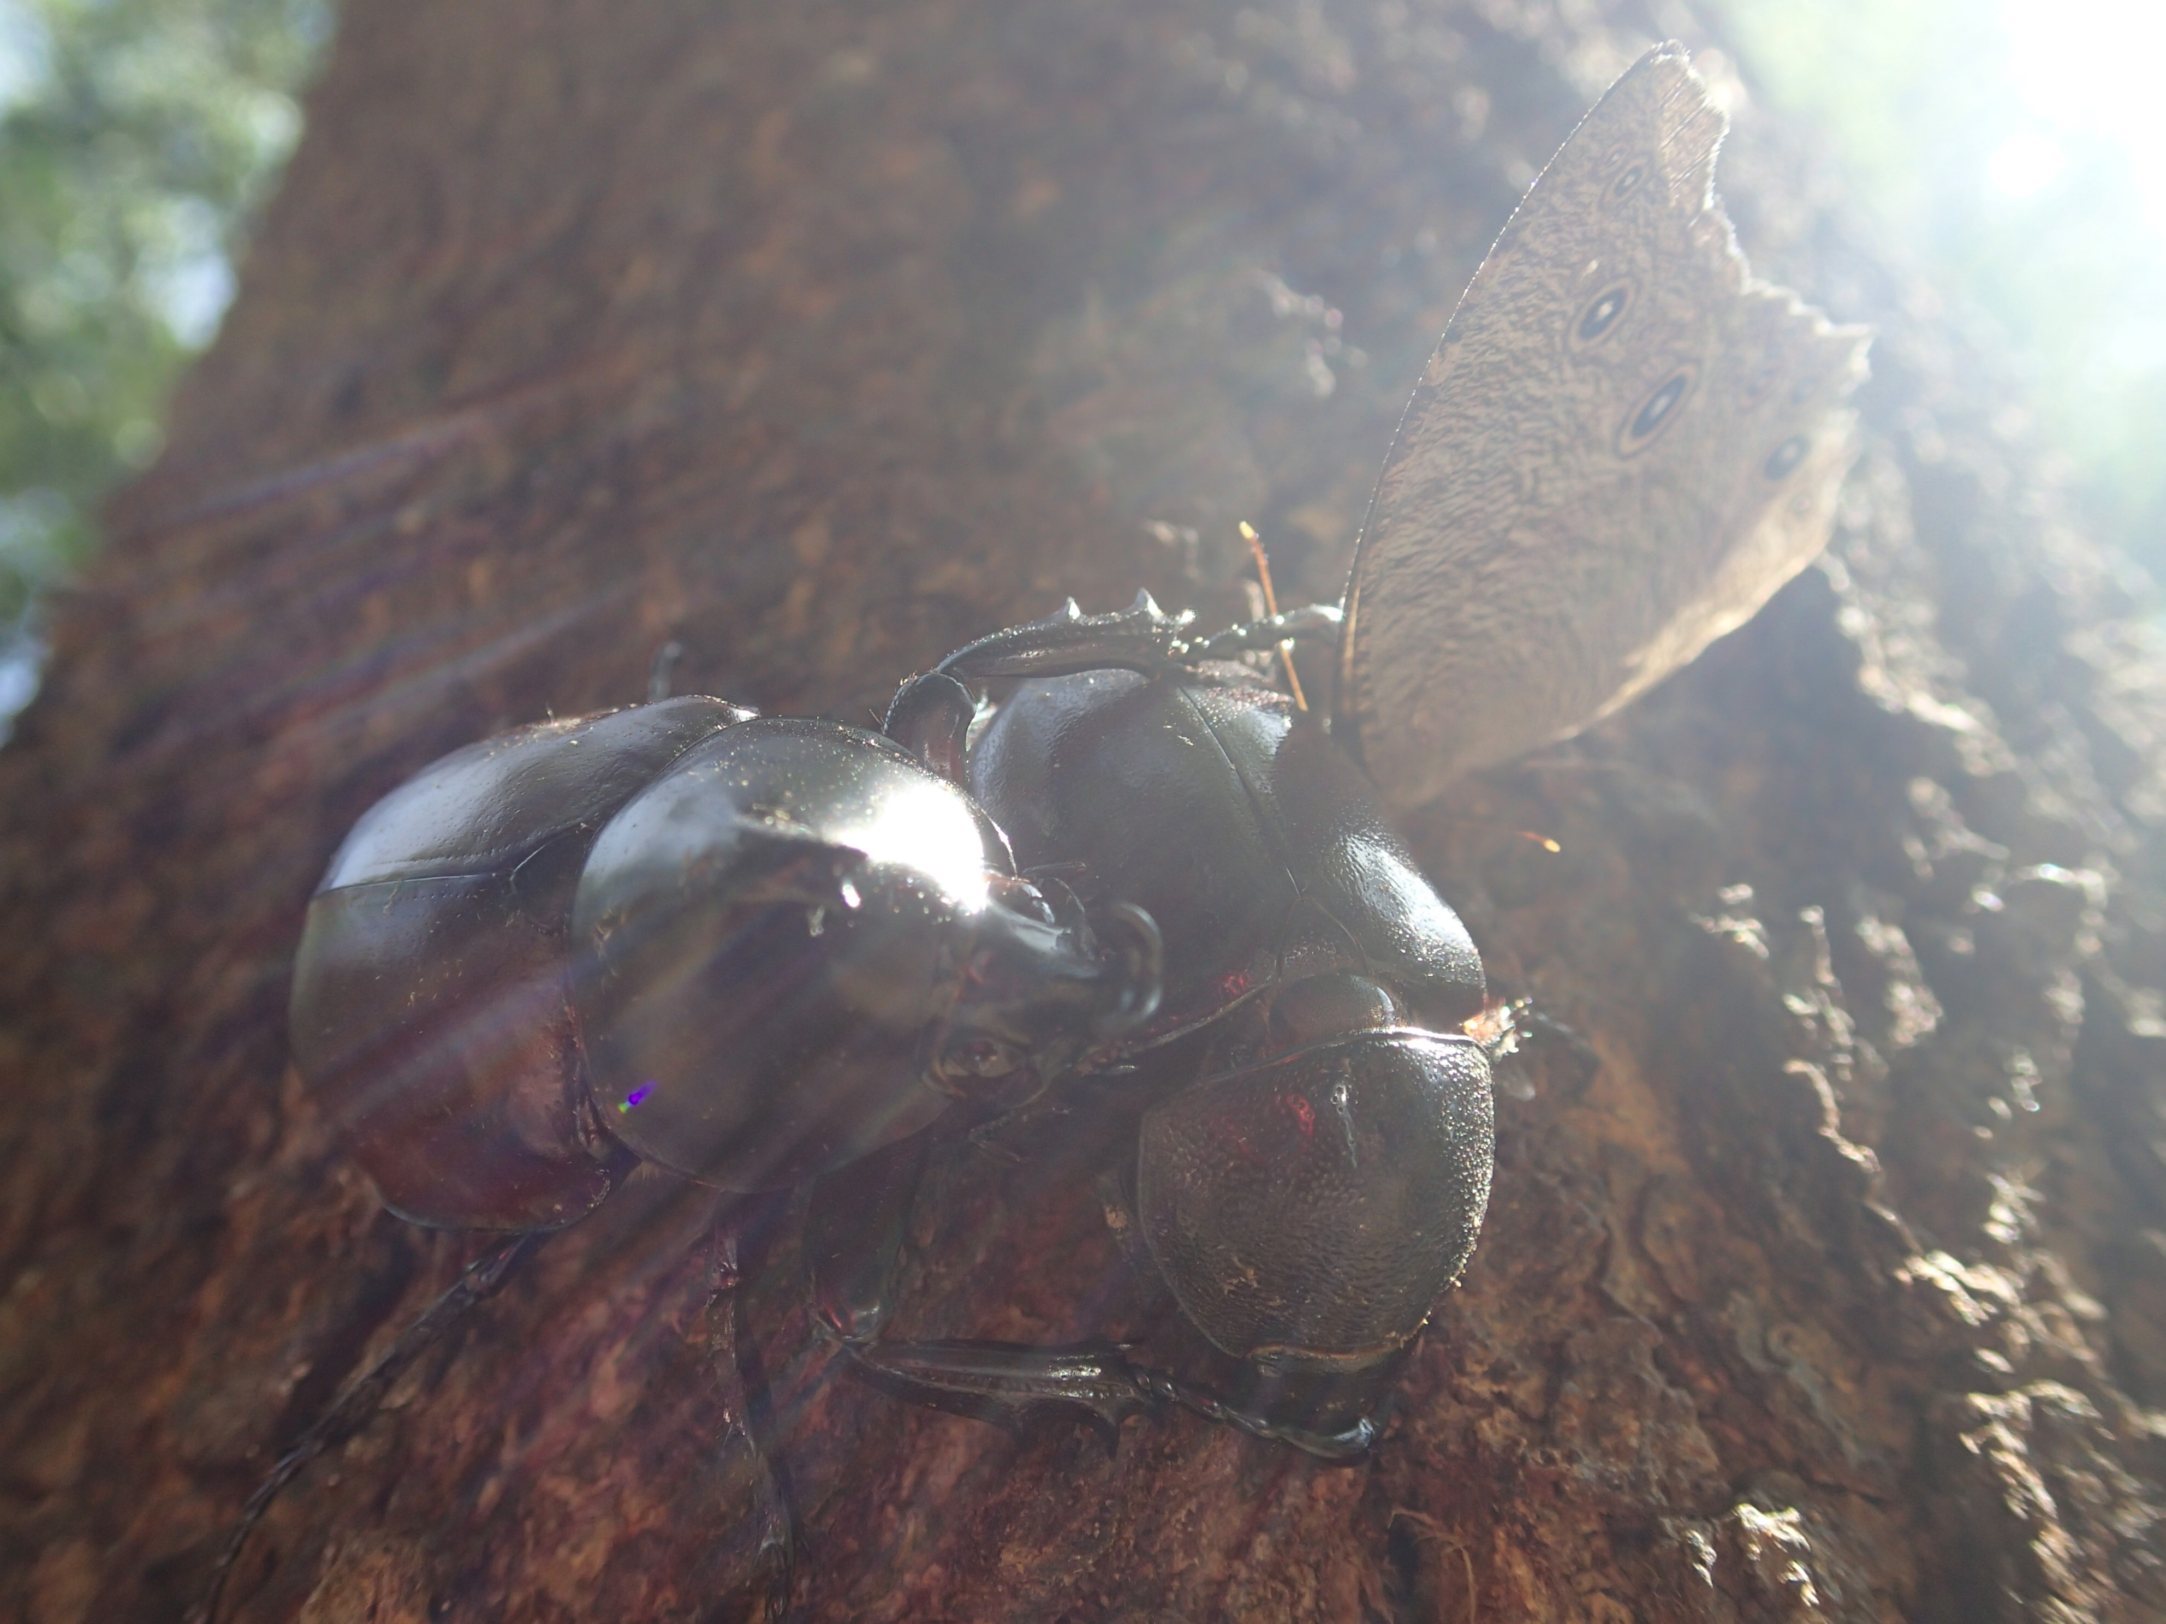

Figure 1. Adult Melanitis leda leda butterfly feeding on the tree sap of Acacia mangium in the company of a mating pair of rhinoceros beetles, Xylotrupes gideon.
Acknowledgements

I am grateful to Pisuth Ek-Amnuay (Siam Insect Zoo) for identifying X. gideon and for his help with my many queries about Thai insects.

Literature Cited

- Tutt, J.W. 1897. The drinking habits of butterflies and moths. Proc. S. Lond. Entomol. Nat. Hist. Soc. 1897: 73-81.
- Scott, J.A. 1973. The interaction of behaviour, population biology, and environment of Hypaurotis crysalus (Lepidoptera). Amer. Midland. Natur. 91: 383-394.
- Scoble, M. J. 1992. The Lepidoptera, Form, Function and Diversity. Oxford University Press, Oxford. 404 pp.
- Molleman, F. 2010. Puddling: from natural history to understanding how it affects fitness. Entomol. Exp. et Appl. 134: 107-113.
- Adler, P. H. 1982. Soil and puddle-visiting habits of moths. J. Lep. Soc. 36: 161–173.
- Holloway, J.D., Barlow, H.S., Loong, H.K., and Khen, C.V. 2013. Sweet or savoury? Adult feeding preferences of Lepidoptera attracted to banana and prawn baits in the Oriental Tropics. The Raffles Bulletin Of Zoology, Supplement No. 29: 71–90.
- Büttiker, W. 1962. Biological and morphological notes on the fruit-piercing and eye-frequenting moths. Proceedings of the Xth International Congress of Entomology, Vienna, 1960, 2: 10–15.
- Büttiker, W. 1967. Biological notes on eye-frequenting moths from N. Thailand. Mitteilungen der Schweizerischen 39: 151-179.
- Banziger, H. 1970. The piercing mechanism of the fruit-piercing moth Calpe [Calyptra] thalictri Bkh. (Noctuidae) with reference to the skin-piercing blood-sucking moth C. eustrigata Hmps. Acta Trop. 27: 54-88.
- Banziger, H. 1975. Skin-piercing blood-sucking moths I: Ecological and ethological studies on Calpe eustrigata (Lepid.. Noctuidae). Acta Trop. 32: 125-144.
- Banziger, H. 1979. Skin-piercing blood-sucking moths II: Studies on a further 3 adult Calyptra [Calpe] sp. (Lepid. Noctuidae). Acta Trop. 36: 23-38.
- Bänziger, H. 1982. Fruit-piercing moths in Thailand: A general survey and some new perspectives. Mitteilungen der Schweizerischen Entomologischen Gesellschaft 53: 127–142.

- Bänziger, H. 1992. Remarkable new cases of moths drinking human tears in Thailand (Lepidoptera: Thyatiridae, Sphingidae, Notodontidae). Nat. Hist. Bull. Siam Soc. 40: 91–102.
- Hawes, T.C. 2015. A melanic morph of Herennia multipuncta (Doleschall, 1859) from Thailand. Arachnology. 16: 262-4.
- Hawes, T.C. 2015. Tree trunk topography modifies the webs of the arboricole spider, Herennia multipuncta (Doleschall, 1859) (Araneae: Nephilidae). Nat. Hist. Bull. Siam Soc. 61: 29-39.
- Hawes, T.C. 2016. Cocoon orientation by Cyana moths on lichen-host trees. Oriental Insects. 50: 111-118
- Hawes, T.C. 2016. Spiders appropriate empty Cyana moth cocoons for nest armour. Nat. Hist. Bull. Siam Soc. 61: 127-130
- Ek-Amnuay, P. 2012. Butterflies of Thailand. Bangkok, Thailand: Baan Lae Suan Amarin Printing, Second edition, 943 pp.
- Butterflies of Singapore. Online at: http://butterflycircle.blogspot.sg/2015/08/life-history-of-common-evening-brown.html (accessed 23/5/2016).

